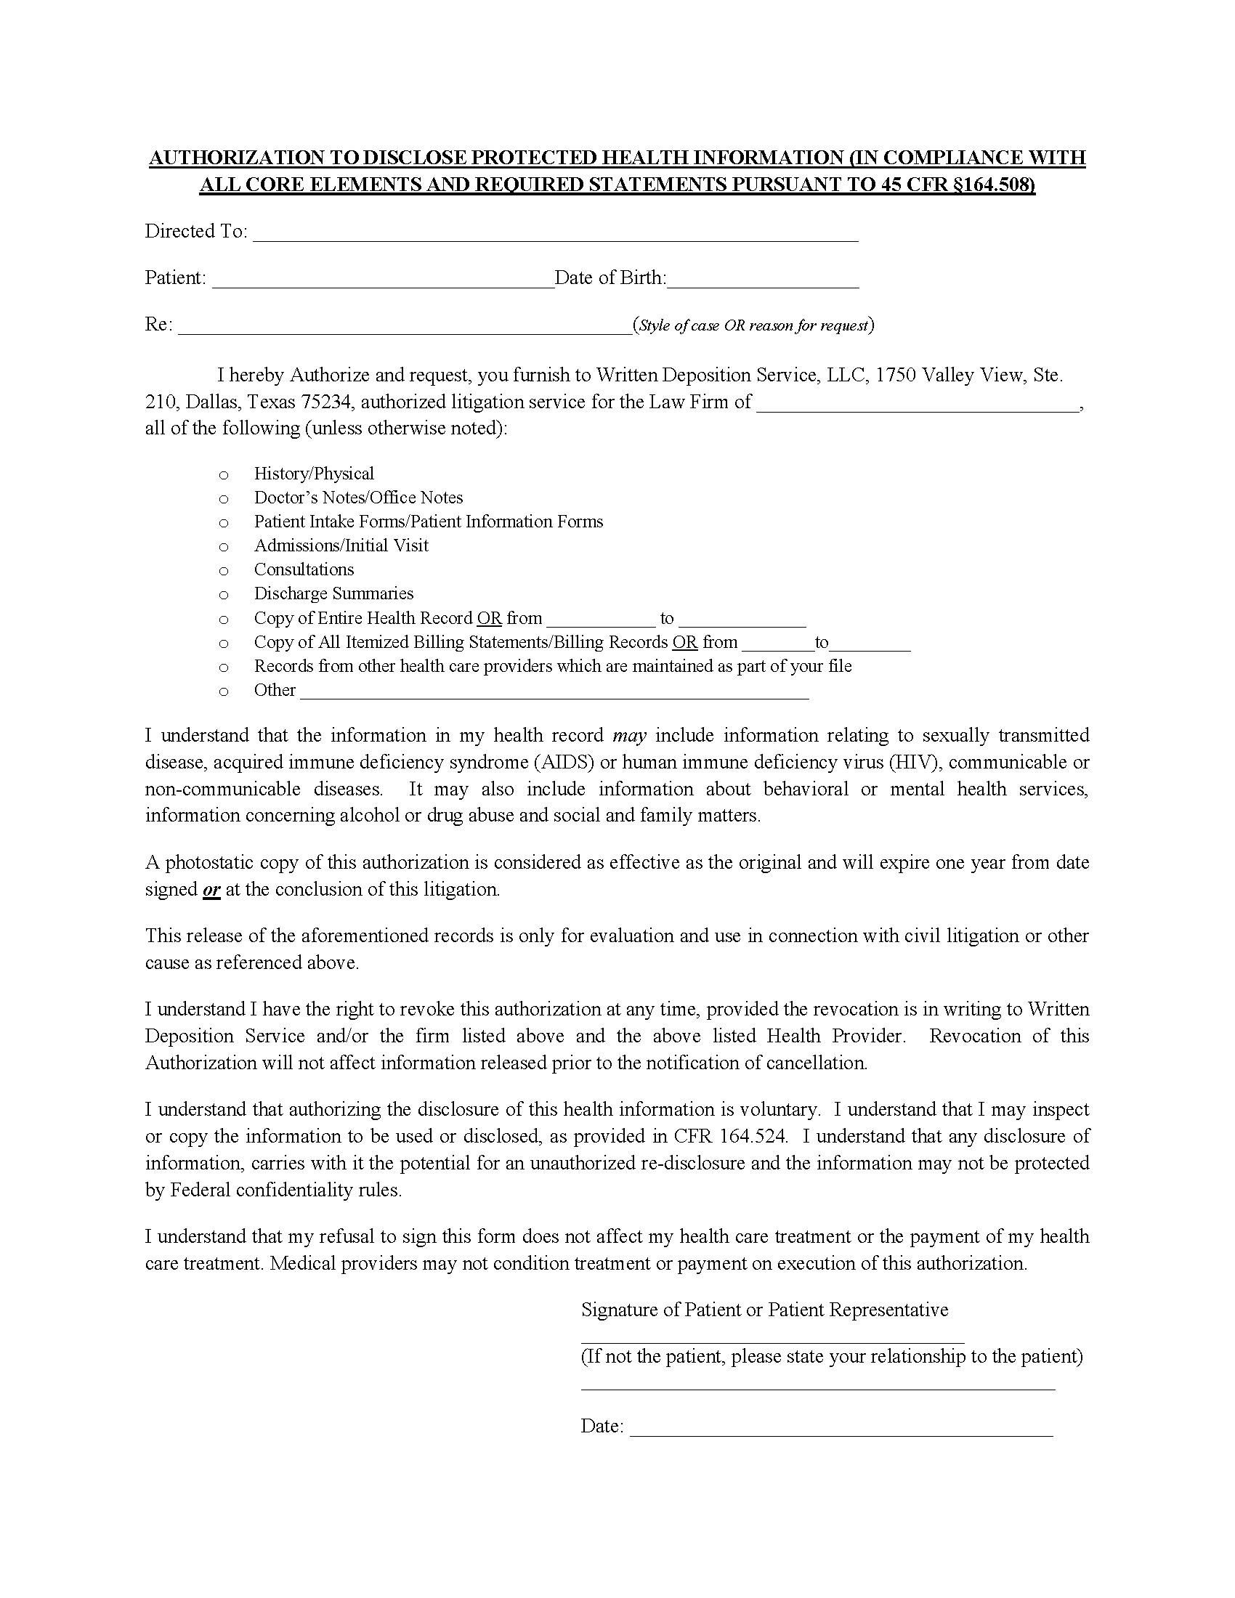
New York Surgery Center Queens f/k/a Boulevard Surgical Center
Jocelyn Brooks
03/08/1968
Crisci, Weiser & McCarthy
Brooks v. Davis, Rodriguez, Aracena's Transport, Inc
Axiom Requisition Copy Service, 2869 Jolly Road
Okemos, MI 48864
03/08/1968
Present
X
Order No. 01-28888-002

